There are two main sources of information, in addition to catches, for most stock assessment methods i.e. i) information on trends in population size e.g. based on Abundance indices obtained from surveys and standardised CPUE series and ii) information on the age structure of catches (Punt and Hilborn 1997). Likelihood formulations for each of these for use in estimating population parameters are presented as full (negative) log-likelihood functions (including all constants) to allow for the use of AIC and similar statistics for model comparisons (Porch 2003, Burnham and Anderson 2002).

Abundance indices

Lognormal likelihood
Assuming that the abundance indices are log-normally distributed about their corresponding model estimates, the negative log-likelihood contribution (-lnL₁) from all series i for which abundance indices are available is as follows:
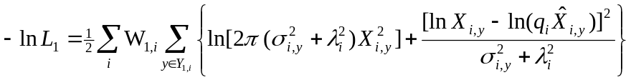 [1]

where
X_{i,y} is the abundance index observation for year y and series i;
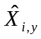 is the corresponding model estimate for X_{i,y};
q_{i} is the constant of proportionality associated with series i;
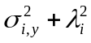 is the residual variance for year y and series i, where 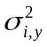 represents the sampling component of this variance associated with each observation (i.e. each year y) of series i, and 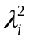 represents the extent of additional variance (over and above that linked to sampling – Punt and Butterworth 2003, Porch 2003) associated with series i;
Y_{1,i} represents the years for which abundance observations are available for series i; and
W_{1,i} is the relative weight given to the abundance index component of the likelihood associated with series i.

The assumption of log-normality allows the sampling component of the residual standard deviation, σ_{i,y}, to be approximated by the CV (coefficient of variation) of the untransformed distributions of the X_{i,y}.

Estimation options for λ_{i} and q_{i}, given σ_{i,y} (a fixed input value) are as follows:
(a) λ_{i} fixed
(i) If λ_{i} = 0 then it is necessary that σ_{i,y} > 0 for all y. Setting σ_{i,y} = 1 for all y reduces equation [1] to a least-squares formulation.

(ii) If λ_{i} > 0 then σ_{i,y} ≥ 0 for all y. Setting σ_{i,y} = σ_{i} for all y (σ_{i} ≥ 0) allows for equal weighting of all observations relative to one another within an abundance series.

If q_{i} is to be estimated, then a closed form solution exists, as follows:
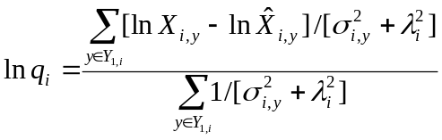 [2]

If σ_{i,y} = σ_{i} for all y, then equation [2] reduces to the following:
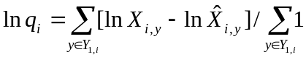 [3]

b) λ_{i} estimated
(i) σ_{i,y} = 0 for all y:
As for (a)(ii) above, this allows equal weighting for all observations within an abundance series. A closed-form solution for λ_{i} exists, as follows:
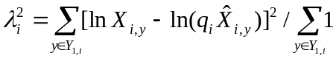 [4]
If q_{i} is also estimated, then the closed-form solution given in equation [3] applies.

(ii) σ_{i,y} > 0:
In this case, a closed form solution for λ_{i} is no longer straight forward. An estimate for λ_{i} can be obtained by treating it as an estimable parameter in the non-linear optimisation of equation [1], or by finding the value for λ_{i} that satisfies the following equation:
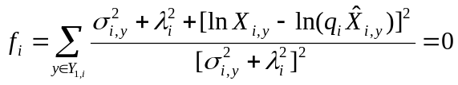 [5]
If q_{i} is also to be estimated, then equation [2] can be used in conjunction with equation [5] to simultaneously solve for q_{i} and λ_{i} using an iterative algorithm. Alternatively, both q_{i} and λ_{i} could be treated as estimable parameters.

References

Burnham, K.P. and D.R. Anderson 2002 – Model selection and multimodel inference: a practical information-theoretic approach. Second Edition. Springer-Verlag, New York: [xxvi] + 488pp.

Porch, C.E. 2003 – VPA-2Box. Version 3.01. User’s Guide.

Punt, A.E. and D.S. Butterworth 2003 – Specifications and clarifications regarding the ADAPT VPA assessment/projection computations carried out during the September 2000 ICCAT West Atlantic bluefin tuna stock assessment session. Col. Vol. Sci. Pap. ICCAT, 55(3): 1028-1040.

